# Benchmark GTX 580 vs. GTX 680 DC2T – 2GD5

Unigine Valley Benchmark 1.0 – DirectX 11 – Ultra – 1920x1080 fullscreen

Intel Core I7 2600k @ 3.4GHz – 2x 4Go RAM DDR3 10666 (1333MHz)   
SSD OCZ Vertex 4 – 256 Gb  
Windows 8 Pro x64 – ForceWare 310.90

GTX 580 – Temp max : 90°c  
GTX 680 DC2T – Temp max : 67°c (-26%)

* **Anti-Aliasing 4X :**

FPS: 37.3   
Score: 1561   
Min FPS: 20.9   
Max FPS: 68.7

FPS: 56.6 *(+51%)*  
Score: 2368   
Min FPS: 26.2 *(+25%)*   
Max FPS: 111.0 *(+61%)*

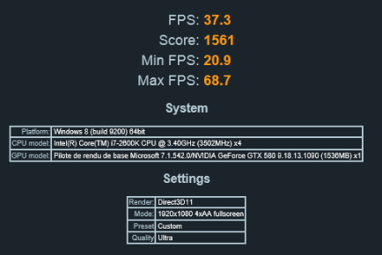 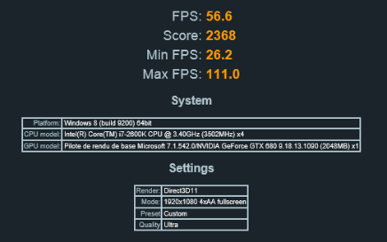

* **Anti-Aliasing 8X :**

FPS: 32.3   
Score: 1350   
Min FPS: 18.7   
Max FPS: 57.2

FPS: 43.5 *(+34%)*  
Score: 1821   
Min FPS: 23.2 *(+24%)*  
Max FPS: 80.4 *(+40%)*

